**STUDENT NAME**:**Sanaullah**

**STUDENT ID:22066704**

**ASSIGNMENT 1**

**Data Source:** https://data.worldbank.org/indicator/NY.GDP.PCAP.CD?end=2022&start=1960&view=chart

**Visualization 1**

Line Plot has been used to visualize the GDP per capita of “Aruba” since 1985 till 2022.

Interpretation: Increasing trend can be seen from 1986 till 2008 and a slight decrease in the GDP per capita then it again increases till 2019 and again a slight decrease in 2020 then its again on a increasing trend in 2021.

**Visualization 2**

Horizontal Bar Chart is used to display the top 10 countries with the highest GDP per capital in 2021.

Interpretation: Monaco has the highest GDP per capita income whereas US has got the least GDP per capita income. Cayman Islands, Norway and Switzerland have got same GDP per capita income.

**Visualization 3**

A pie chart has been used to visualize the GDP contribution in 2021 and only the top 10 countries are visualized with top contributions.

­­­­-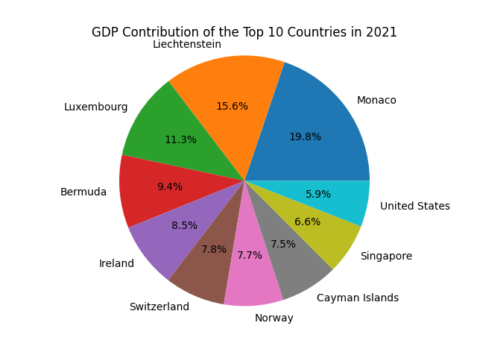

Interpretation:

As per the Pie chart, Monaco is contributing with highest contribution percentage of 19.8% following to the least percentage of 5.9% of United states.